Project: Car Rental Application
Documentation

Made by
Emmanouela Zapanti
Sahar Zar
Zeynep Multu

Using IntelliJ
--------Information about the developers------

Name: Emmanouela Zapanti
Faculty Number: 23221030
Email: emmaz102005@gmail.com

Name: Sahar Zar
Faculty Number: 2250004
Emai: Saharzar77@gmail.com

Name: Zeynep Mutlu
Faculty Number: 23221029
Emai: zeynep.mutlu6847@gmail.com

Institution: Technical University of Varna

--------The Project------
Contents
General Information about the project…………….……...….5

Chapter 1. The lead
  - Description of the idea of the project…………..……..6
  - Purpose and objectives of the development……….….6
  - Structure of the documentation ………………………6

Chapter 2. Overview of the subject area
2.1 Basic definitions, concepts and algorithms to be used…....7
2.2 Defining problems and complexity of the task……..……..8
2.3 Approaches, methods for solving the problems posed........9

Chapter 3. Design
3.1 General structure of the project…………………………..9
3.2 Relational Model – Diagram………………………..…...10
3.3 Description of the classes………………………………..11

Chapter 4. Implementation, testing
4.1 JUnit Tests……………………………………………...12
4.2 Functional and Integration testing……………………...20

Chapter 5. Conclusion
5.1 Summary of the implementation of the initial objectives..36
5.2 Directions for future development and improvement……36

Bibliography and References…………………….…………..38

Introduction

General Information about the project
The purpose of the Car Rental project is to create an application the combines the use of an Oracle Database, JPA/Hibernate, JavaFX and Log4j in one system for car rentals. Available are functions for handling database data, authenticating user or admin and printing relevant information.

(The task description is included in the .zip folder.)

Analysis of the task and approach to solving
The nature of the task is simple enough and can be divided into parts:
- Into the ‘resources’ package we have all the JavaFX files for the interface and other ‘pages’ of the application. Also the .css file for customizing the ‘pages’. And the ‘META-INF’ contains the ‘persistence.xml’ used in the implementation of JPA for the database layer.
- Into the ‘java’ package we have the application, controller, Database, enums, models, service and testing. The ‘application’ package includes the starting point of the application and the main body. The ‘controller’ package includes the classes with the methods each component is executing in FXML. It is the action of the whole graphic interface. The ‘Database’ package includes all the classes related to the database connection (split into jpa and jdbc – two database approaches to data handling and mapping), testing of the connection and methods using queries and handling database data with JUnit and integration test. The ‘enums’ package includes all the enums we are using throughout the program. The ‘models’ package includes all the classes that are used or instantiated, for example the car class, admin , operator, rental etc...This is the base of our program ,( also split into jpa and jdbc). It is important to mention that the ‘jpa’ approach includes all the entities necessary for mapping the database data to out application input, and helper classes for the reports of them. The ‘service’ package includes two classes. The service related to the admin and the operator, with methods for each one.
Chapter 1: The Lead

  - Description of the idea
The main idea of the Car Rental project is to create a program that handles database data, includes an interface and operates as something so far new. A guided user interface (GUI) !. The most intriguing functionality is the user authentication, and the way JavaFX is implemented in combination with the database connection. JPA and entity mapping is also worth mentioning.

  - Purpose and objectives of the development
During the development of the project the main goal was to keep things as simple as possible, always having the SOLID principles in mind. The main objective was a simple, efficient program that is easy and user-friendly, also:
- Handles Database Data (Oracle Database)
- Uses JavaFX
- Uses Log4j
- Runs JUnit and Functional/Integration tests

  - Structure of the documentation
It consists of the following:
- Introduction(General Information)
- Main Body (About the program, its development, its functions and capabilities. It contains a description of different aspects of the development process, objectives and goals.
- Conclusion (Sum up of purpose, objectives and future opportunities for improvement)

Chapter 2. Overview of the subject area

2.1 Basic definitions, concepts and algorithms to be used
The Car Rental project is a desktop application developed in Java, combining a graphical user interface with database operations. The system is designed to manage car rental activities such as authentication, car availability, rental management, and reporting.
The main concepts and technologies used in the project are:
- JavaFX
JavaFX is used to build the graphical user interface (GUI). It allows the creation of interactive windows, buttons, tables and scenes that guide the user through the application. The interface is defined using .fxml files, which separate the design from the application logic.
- Oracle Database
The Oracle Database is used to store all persistent data, such as cars, clients, rentals, users, and condition reports. Using a relational database ensures data consistency, integrity, and structured storage through tables and relationships.
- JDBC (Java Database Connectivity)
JDBC is the technology that enables communication between the Java application and the Oracle Database. It is used to establish connections, execute SQL queries, retrieve results, and update database records.

- Alternative to JDBC, offering a more controlled entity mapping for our input and database data is JPA. This available logic in our program makes the database reports and handling of data operations easier. It gives the program an extra layer , the database one!
- MVC Architecture (Model–View–Controller)
- Model: Represents the business entities such as Car, Client, Rental, and User.
- View: Implemented using JavaFX .fxml files.
- Controller: Handles user actions and connects the interface with the business logic.
  - Logging (Log4j)
Log4j is used to record important system events such as database connections, errors, and user actions. Logging helps in debugging and monitoring the behavior of the application.
The algorithms used in the project are straightforward and mainly focus on:
- User authentication (checking credentials)
- User and Client registration
- Rental creation and completion
- Status updates for cars and rentals
- Basic reporting using database queries

2.2 Defining problems and complexity of the task
Problems encountered:
- Database connectivity
Establishing a stable connection between the Java application and the Oracle Database required correct configuration of JDBC drivers, connection parameters, and SQL queries.
- Data consistency and relationships
Managing relationships between entities such as Cars, Clients, Rentals, and Operators required careful database design using primary and foreign keys.
- User authentication and roles
The system supports different user roles (Administrator and Operator). Ensuring that each role has access only to its allowed functionalities added logical complexity to the application.
- User interface navigation
Designing a clear and user-friendly GUI with multiple scenes required careful control of navigation between screens and correct event handling.
- Error handling
Invalid user input, database errors, and unexpected behavior needed to be handled gracefully to prevent application crashes.

2.3 Approaches, methods for solving the problems posed
Layered project structure
The application was divided into packages such as ‘models’, ‘Database’, ‘service’, ‘controller’, ‘resources’, ‘application’ and ‘testing’. This separation improves readability, maintainability, and scalability.
Encapsulation of database logic
All database-related operations were placed in the package ‘Database’, in dedicated classes, isolating SQL queries from the rest of the application logic.
One package for JDBC and one for JPA.
Use of enums
Enumerations were used for fixed values such as car categories, rental status, roles, and damage levels. This reduces errors and improves code clarity.
Event-driven programming
JavaFX controllers handle user actions such as button clicks and form submissions, ensuring a responsive and interactive interface.
Simple and clear logic
The business logic was kept simple and readable, focusing on correctness rather than unnecessary complexity.

Chapter 3. Design

3.1 General structure of the project, packages to be implemented
The Car Rental Project is built with a layered software architecture that separates the user interface, data storage, and business logic while keeping our project organized. It is also structured into different packages, each one with a specific responsibility:
- application: Has the core application/entry point (EntryPoint.java )and the main logic (MainApp.java).
- models: The data layer holds mandatory business objects (Car, Client, Rental, User). One package for JDBC objects and one for JPA entities.
- Database: Data access layer, handles all communications with the Oracle Database. And query related methods. One package for JDBC and one for JPA.
- service: Encapsulates all the actions related to renting.
- enums: Holds enumeration types.
- controller: Manages the JavaFX user interface and handles the user input/output.
- resources: Contains JavaFX .fxml files. And persistence.xml.

3.2 Relational Model – Diagram
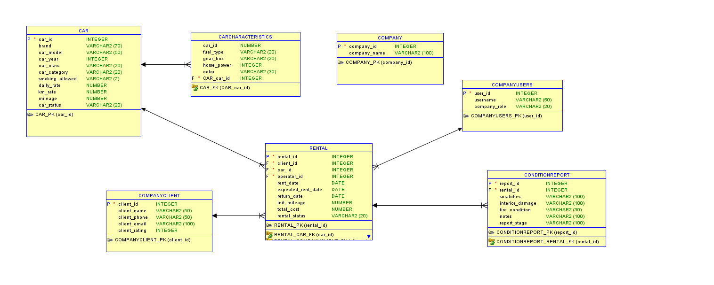
Figure 1. SQL developer. Car Rental project relational database model.

Here is the relational model, showing the relationships between the entities used in Car Rental project.

3.3 Description of the classes
- Car: A rentable vehicle. Has an association with CarCharacteristics.
- CarCharacteristics: Detailed specifications for a Car.
- Client: A rental Customer has an attribute (risk) for risk assessment.
- Rental: Links a Client, Car, and an Operator for a transaction entity.
- User: A type of system user.
- AdminService: Manages administrative functions.
- OperatorService: Daily rental operations.
- DBQueries: Contains methods (static) for every database interaction.
- DatabaseConnection: Manages JDBC parameters to the Oracle Database
- ConditionReport: Documents vehicle condition before and after rental period.
- Enumeration Classes: CarClass(LUXURY, FAMILY, SPORT, CITY), Category(SEDAN, SUV, WAGON, COUPE), CarStatus (AVAILABLE, RENTED), RentalStatus(ACTIVE, COMPLETED), CompanyRole(ADMIN, OPERATOR), DamageLevel(NONE, MINOR, MAJOR). ReportStage( END, START).

Chapter 4. Implementation, testing
4.1 JUnit Tests
In this chapter the testing of the main functions of the program is presented. More specifically, into units.
- ‘createCompany’
The ‘COMPANY’ table.
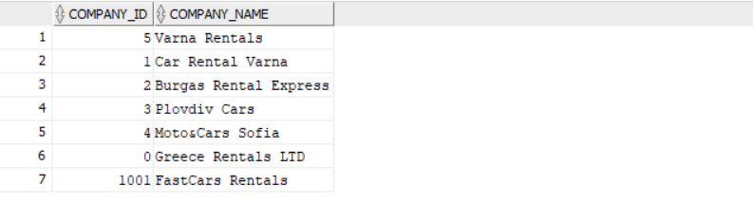
Figure 2. Database table showing Companies. Oracle Database Screenshot.
After running:
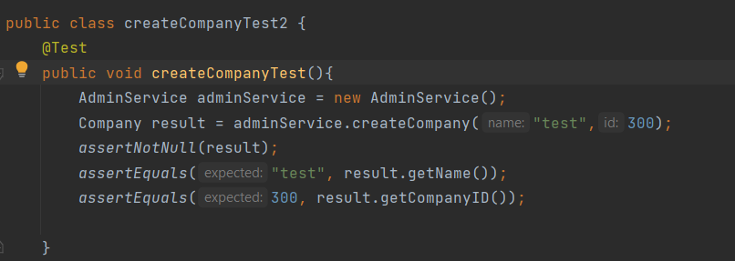
Figure 3. Code snippet. Testing createCompany method.
The result:
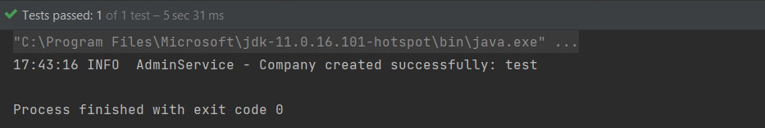
Figure 4. Terminal output.

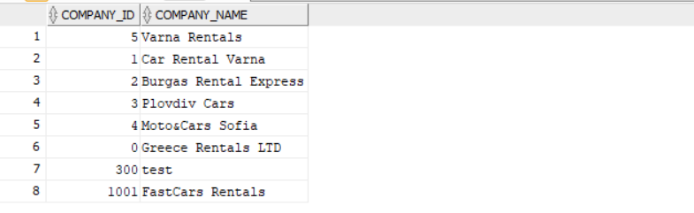
Figure 5. Database with the new company.

- ‘createOperator’
The ‘COMPANYUSERS’ table.
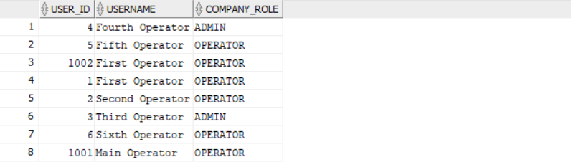
Figure 6. Table with Users. Oracle Database screenshot.
After running:
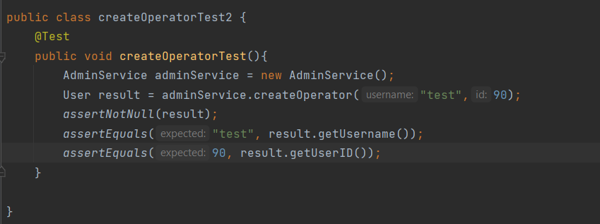
Figure 7. Code snippet. Testing createOperator method.
The result:
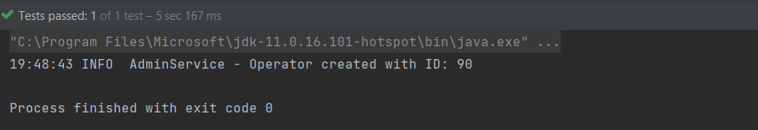
Figure 8. Terminal output. Success.
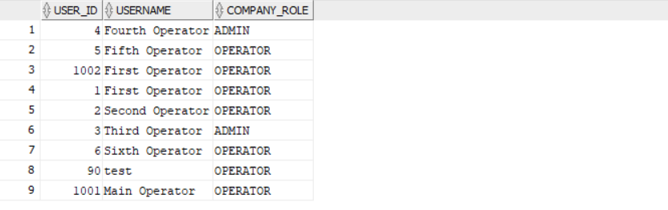
Figure 9. Table with the new Operator.
- ‘authenticate’
We run the method with invalid ID:
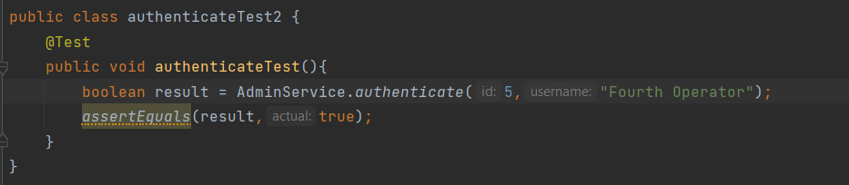
Figure 10. Code snippet. Testing authenticate admin.
A warning is given:
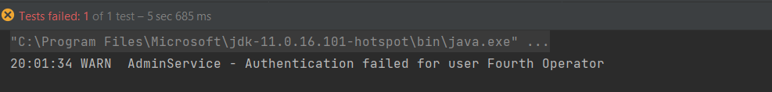
Figure 11. Terminall result after invalid ID.
Now with a correct ID:
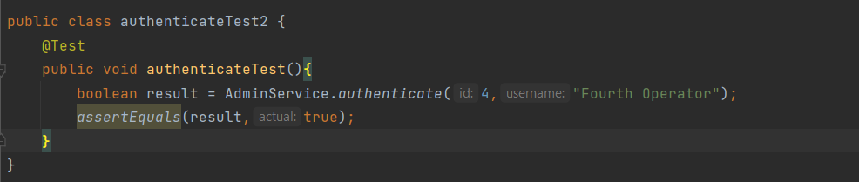
Figure 12. Re-test with correct ID. Code snippet.
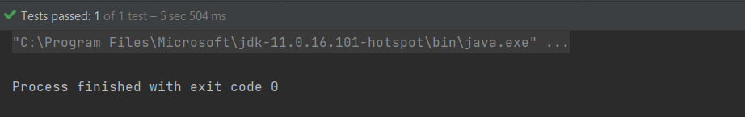
Figure 13. Terminal output. Success.

- ‘registerClient’
The ‘COMPANYCLIENT’ table.
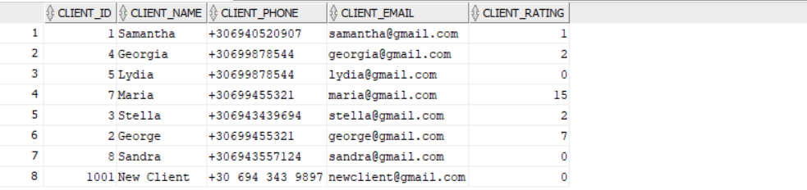
Figure 14. Table with Clients. Oracle Database screenshot.
After running:
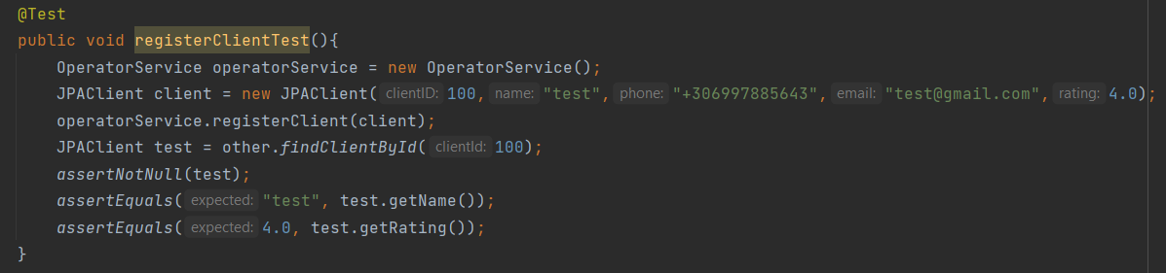
Figure 15. Code snippet. Testing registerClient.
The result:
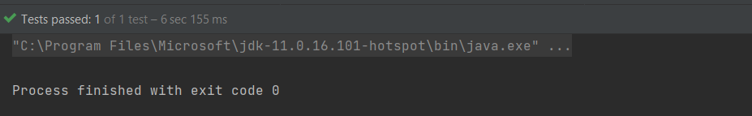
Figure 16. Terminal result. Success.
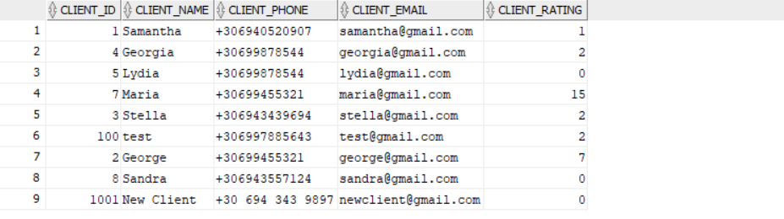
Figure 17. Table with the new Client.

- ‘startRental’
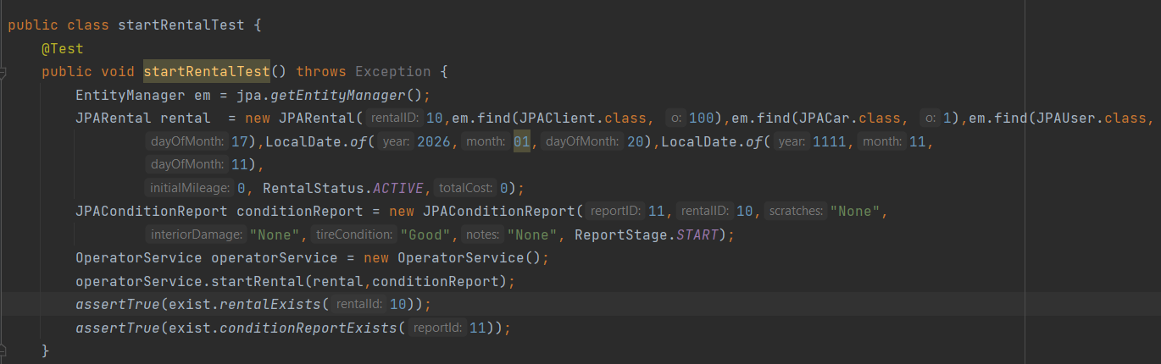
Figure 18. Code snippet. Testing startRental.
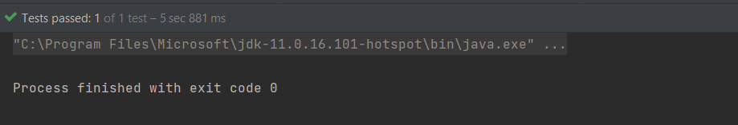
Figure 19. Terminal result. Success.

- ‘endRental’
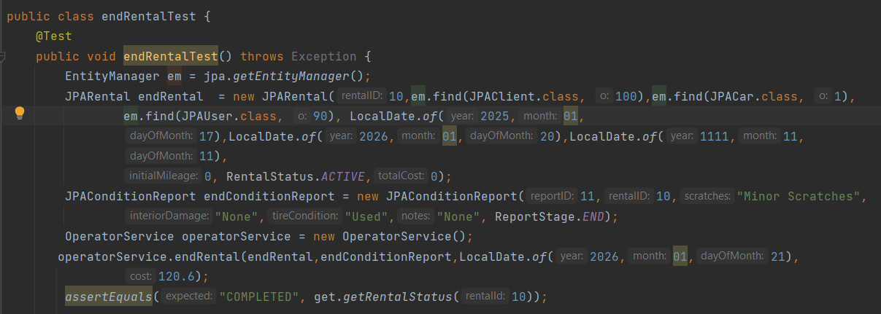
Figure 20. Code snippet. Testing endRental.
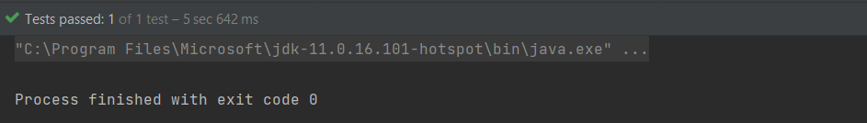
Figure 21. Terminal result. Success.

- ‘regitsterCar’
The ‘CAR’ table.
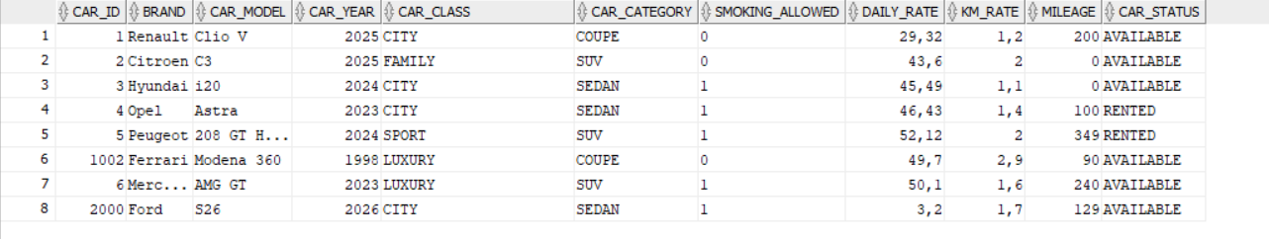
Figure 22. Table with Car entities. Databas Oracle screenshot.
After running:
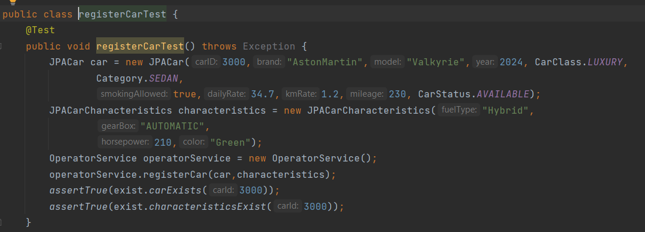
Figure 23. Code snippet. Testing registerCar.
The result:
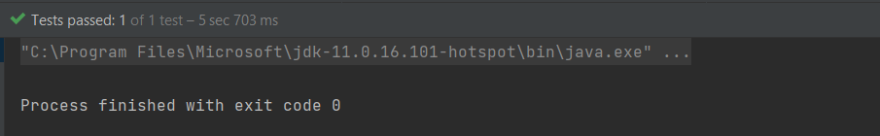
Figure 24. Terminal result. Success.
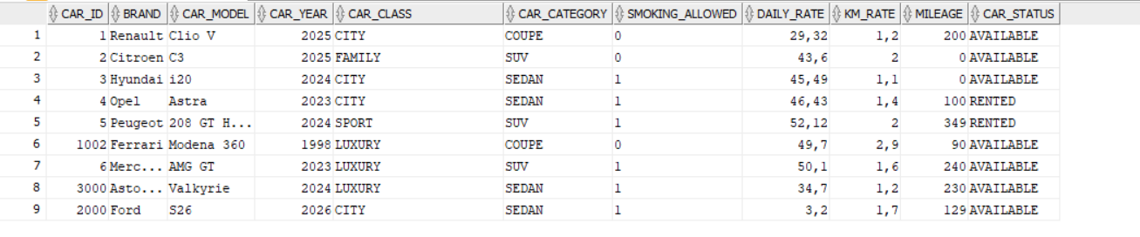
Figure 25. Table with the new Car.

- ‘taxCalculator’
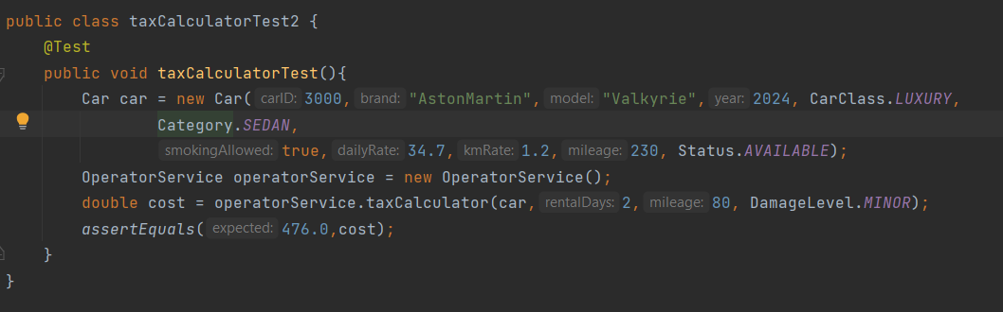
Figure 26. Code snippet. Testing taxCalculator.
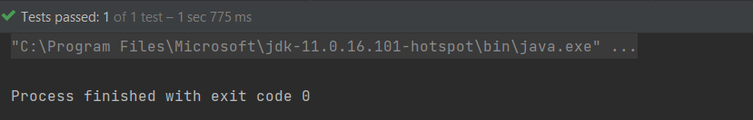
Figure 27. Terminal result with the final cost.

- ‘authenticate’ for Operator this time.
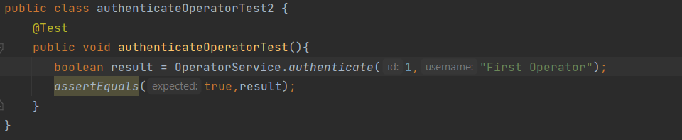
Figure 28. Code snippet. Testing authenticate for operator.
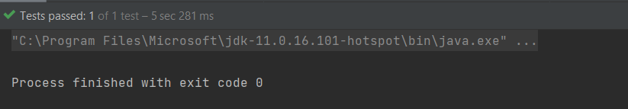
Figure 29. Terminal result. Success.
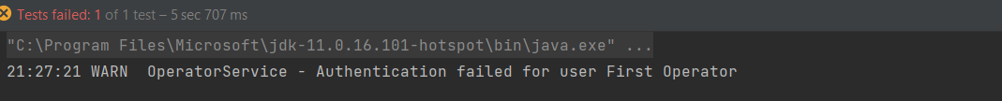
Figure 30. Terminal result given incorrect ID.

In the next sub-chapter follows functional and integration testing. Demonstrating the working of the application.

4.2 Functional and Integration testing
In this chapter the functioning of the program is demonstrated in parts. About the Functional Testing, the main functions of the program are tested. About the Integration testing, the connection to the database and the data passing throughout the program are tested expecting the correct output.
At the start of the program an authentication logic is used:
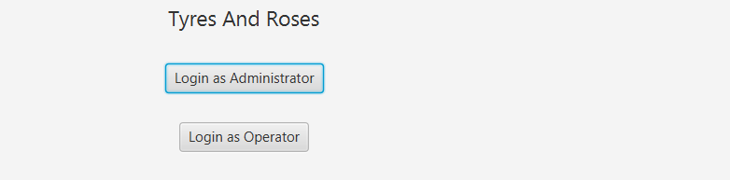
Figure 36. Program's GUI first page.
Login as Administrator, it requires that Username and ID exist in the Users table(in our database). The validation is done where the role is set to ‘ADMIN’. The action is triggered with the ‘Submit’ button.
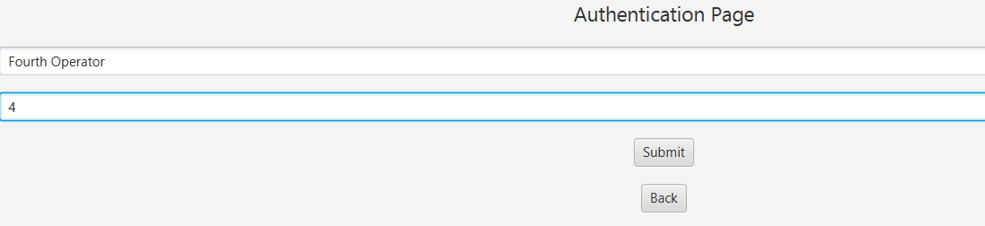
Figure 37. Admin's authentication page.
The result is the Admin’s dashboard.
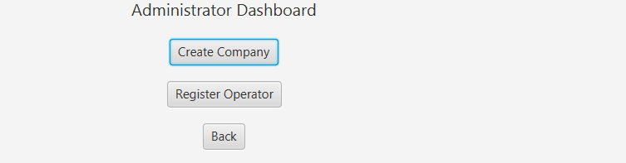
Figure 38. After log in. Administrator's dashboard.

Login as Operator, requires that the Username and ID exist in the Users table. The validation is done where the role is set to ‘OPERATOR’.
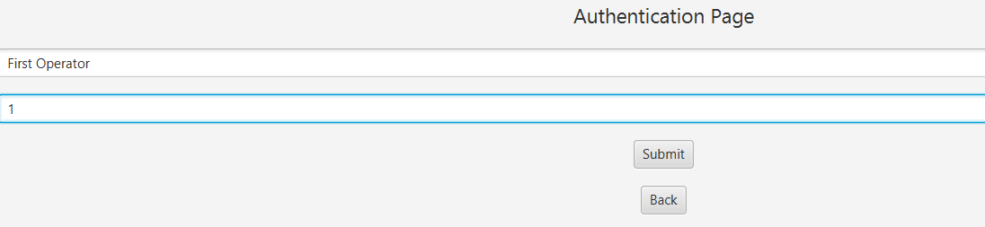
Figure 39. Operator's Login Page.
The result is the Operator’s dashboard:
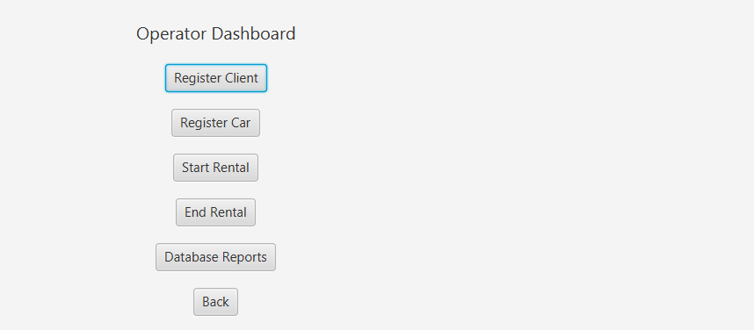
Figure 40. After log in. Operator's dashboard.
When the Operator logs in, some notifications regarding the Expired Rentals and Risky customers are shown:
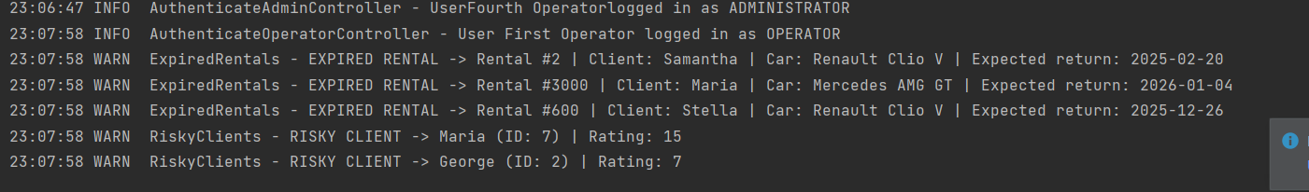
Figure 41. Notifications about Expired Rentals and Risky Customers.

Before starting the actual application, we can test the database connection.
At the ‘Database’->’DatabaseConnection’ , the connection looks like:
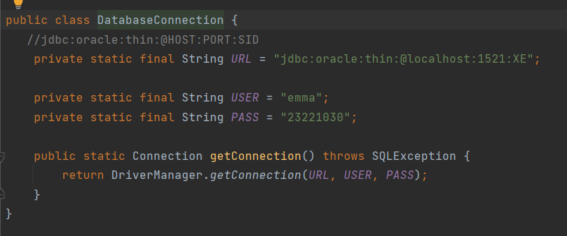
Figure 42. Database connection class. Code snippet.
At the ‘Database’->’TestConnection’ and run. For testing.
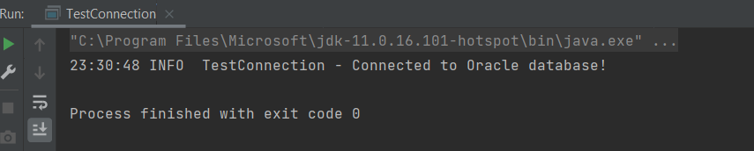
Figure 43. Terminal result. Testing DatabaseConnection.

Continuing with the Admin Services.
- ‘createCompany’
The database before the new company insertion is as follows:
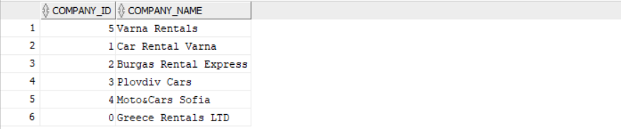
Figure 44. Table with Companies. Database Oracle screenshot.

In the administrator’s dashboard we select the first option.
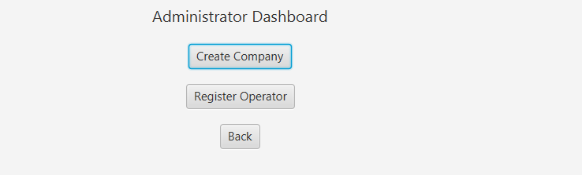
Figure 45. Admin's Dashboard.
Fill out the information.
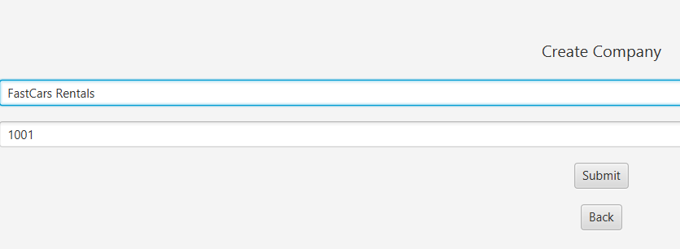
Figure 46. Create Company forms.

After pressing ‘Submit’, we can see the newly added company with ID 1001.
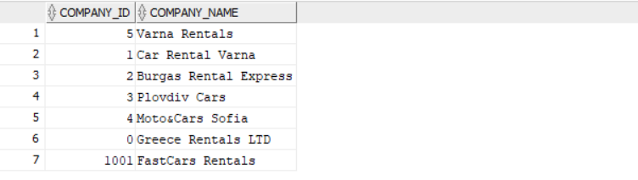
Figure 47. Table with the new Company.
- ‘createOperator’
The database before the new operator is as follows:
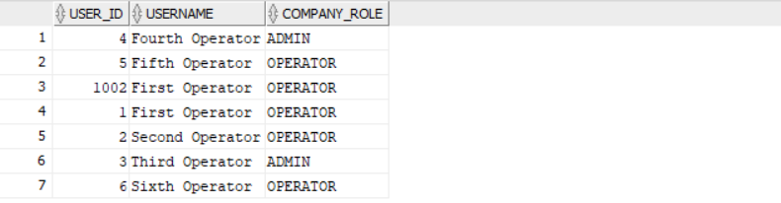
Figure 48. Table with Users. Oracle Database screenshot.
In the administrator’s dashboard we select the second option.
Figure 49. Admin's Dashboard.

We fill in the information.
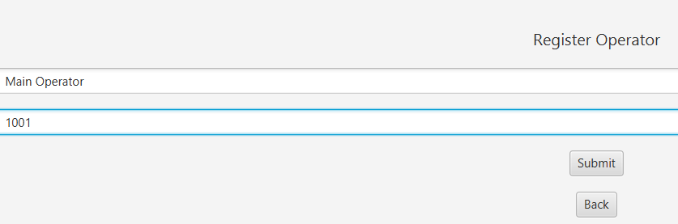
Figure 50. Register Operator forms.
The database after pressing the ‘Submit’ button is as follows:
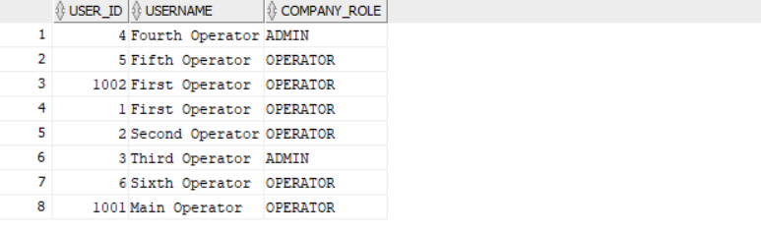
Figure 51. Table with the new Operator.
Next with the Operator Services.
- ‘registerClient’
The database before the new client is:
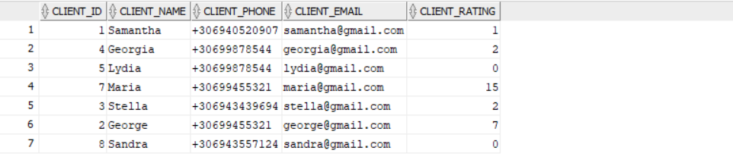
Figure 52. Table with Clients. Oracle Database screenshot.

At the operator’s dashboard we select the first option.
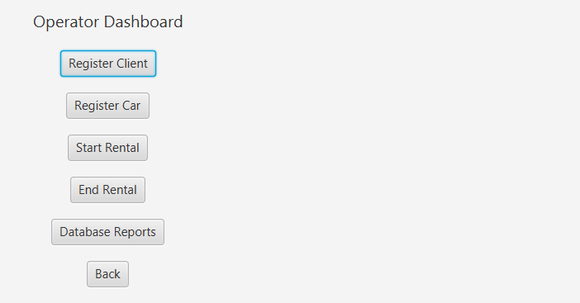
Figure 53. Operator's Dashboard.
We fill out the information.
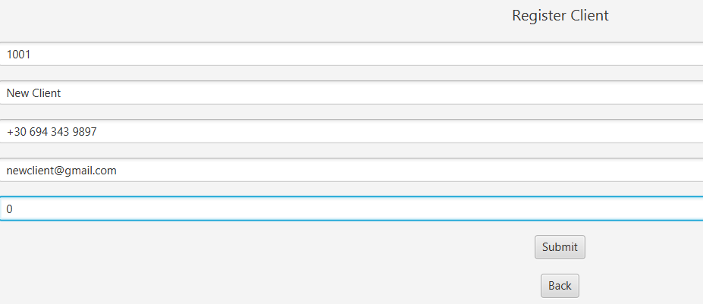
Figure 54. Register Client forms.
After pressing the ‘Submit’ button, the database:
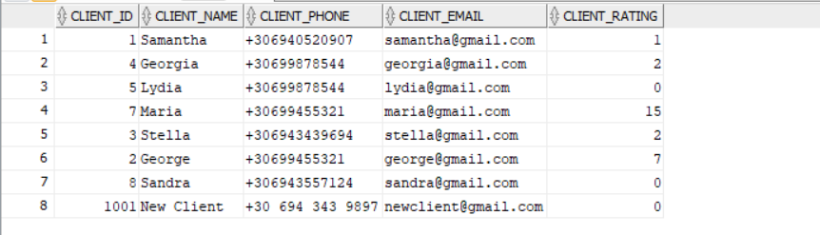
Figure 55. Table with the new Client.

- ‘startRental’
The database before the new Rental is:
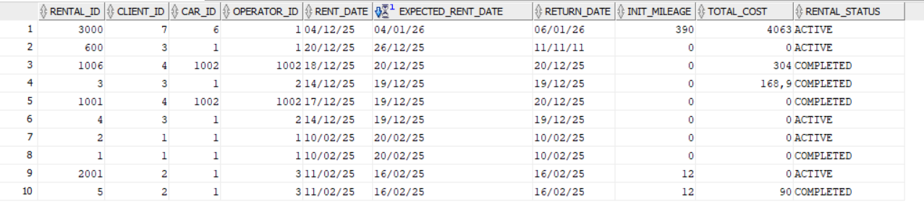
Figure 56. Table with Rentals.
At the operator’s dashboard we select the third option:
Figure 57. Operator's Dashboard.

We fill out the information:
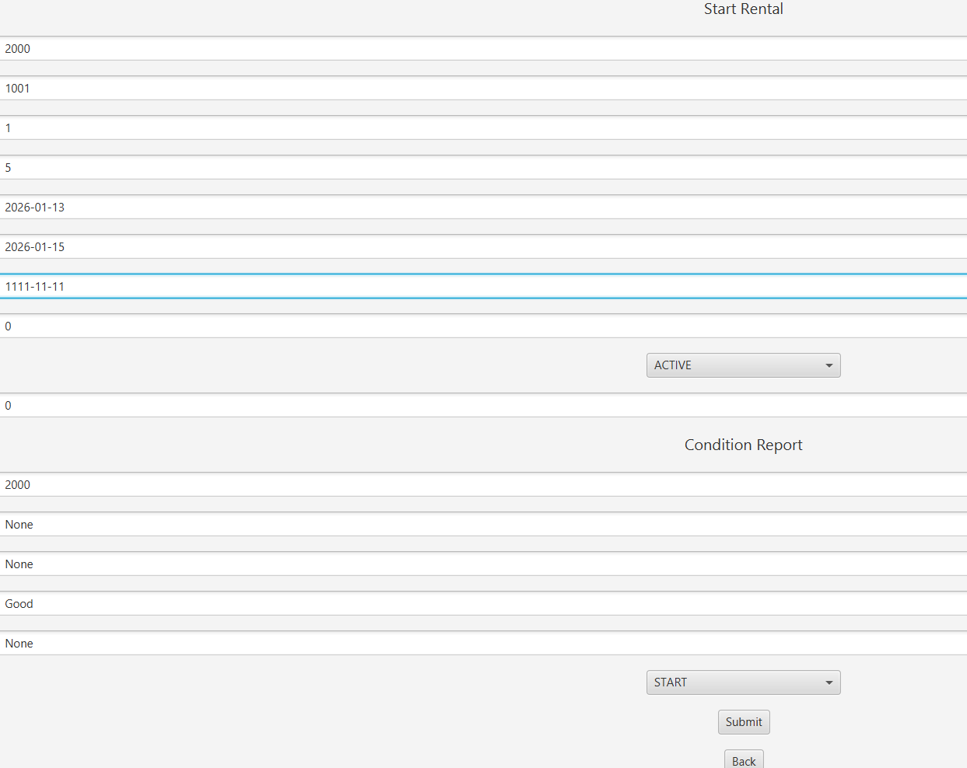
Figure 58. Start Rental forms.
It is noticeable that at the Return Date field we put 1111-11-11 as it must be filled but the date itself is not known yet. It will be updated when the rental ends. Same for the Cost field and whatever damages are caused later.
The database after the new Rental is:
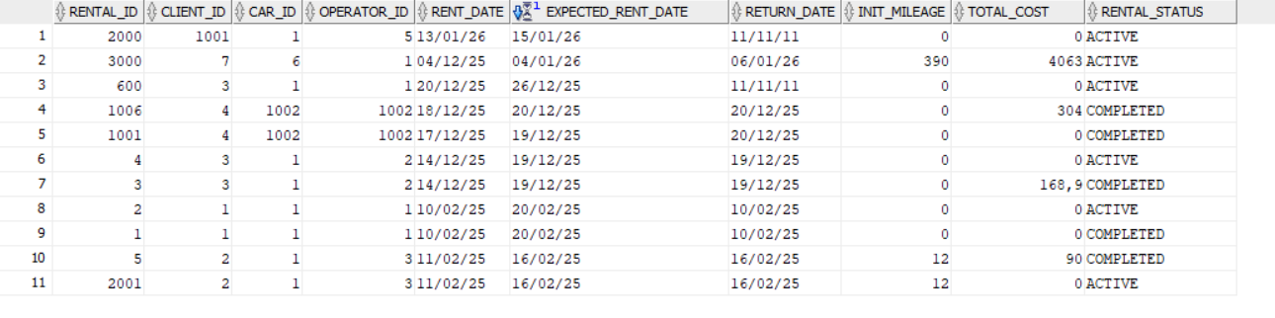
Figure 59. Table with the new Rental.

The condition report also:
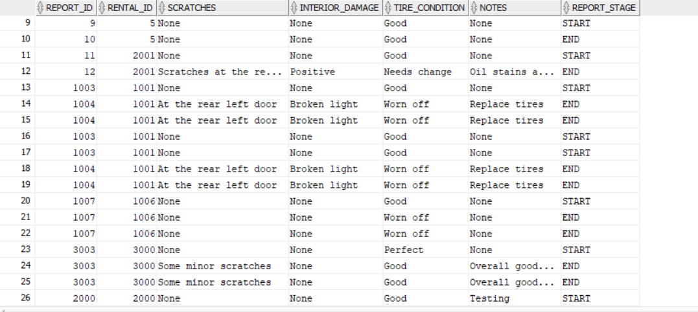
Figure 60. Table with the new Condition Report.
The car status is set to ‘RENTED’.
Figure 61. Car table, showing the status changing to 'RENTED'.
- ‘endRental’
At this moment the Rental Status is set to ‘ACTIVE’ after ending the rental it will be updated to ‘COMPLETED’.
Figure 62. Operator's Dashboard.

We select the fourth option. And fill the information.
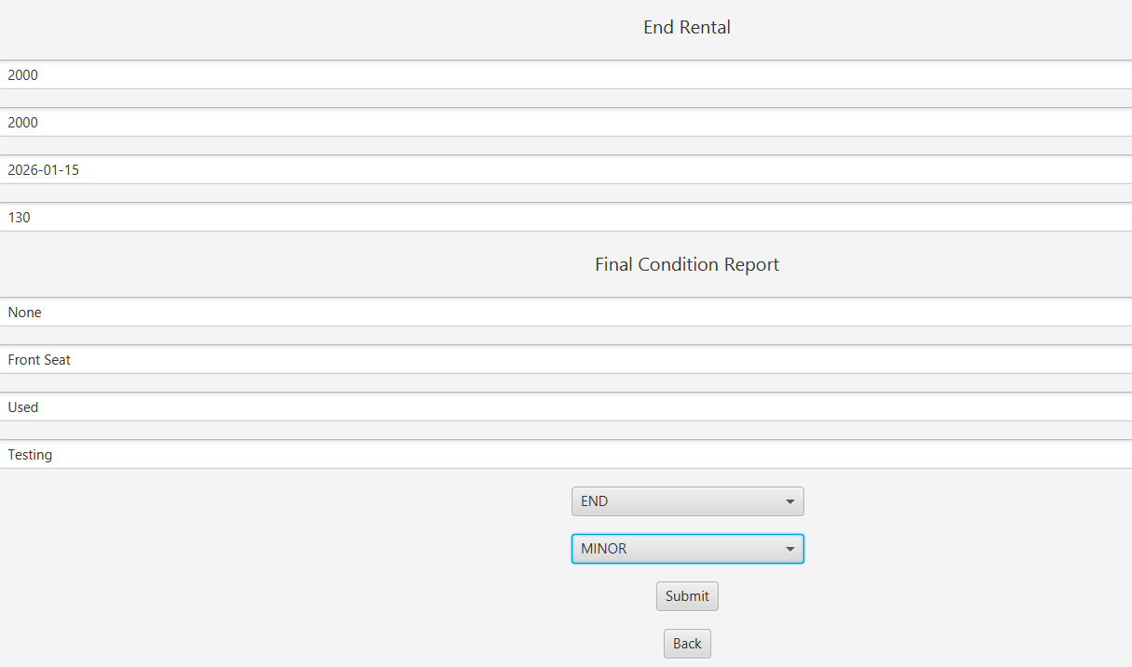
Figure 63. End Rental forms.
The rental ID must be the same , also the report ID. Here we update the Return Date and the final Mileage. The rental status is set to ‘COMPLETED’ and we put some minor damages that lead to extra charges in the final cost.
The database:
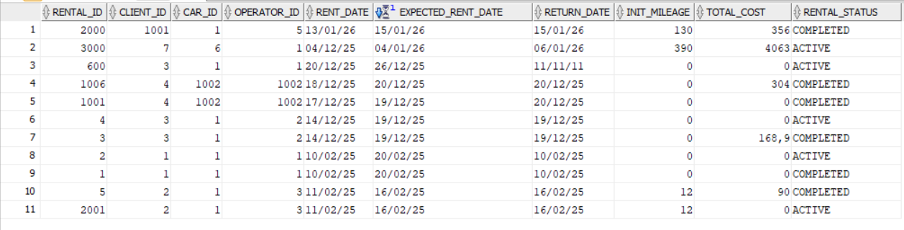
Figure 64. The table, showing how the Rental status changed to 'COMPLETED'.

We have a new Condition Report:
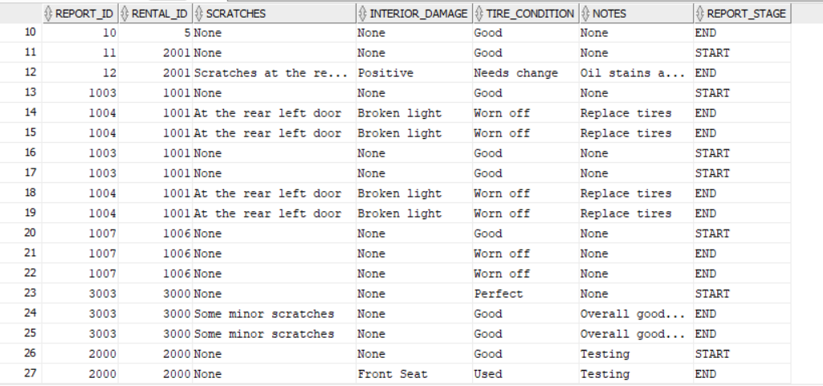
Figure 65. Table with new Condition Report.
The car status is set to ‘AVAILABLE’ again and the extra mileage is updated.
Figure 66. Car table, showing the status changing to 'AVAILABLE' and extra mileage updated.
- ‘registerCar’
The database before the new Car:
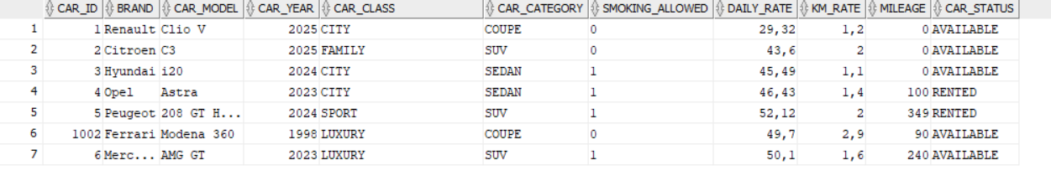
Figure 67. Table with the Car entities.

We select the second option:
Figure 68. Operator's Dashboard.
We fill out the information.
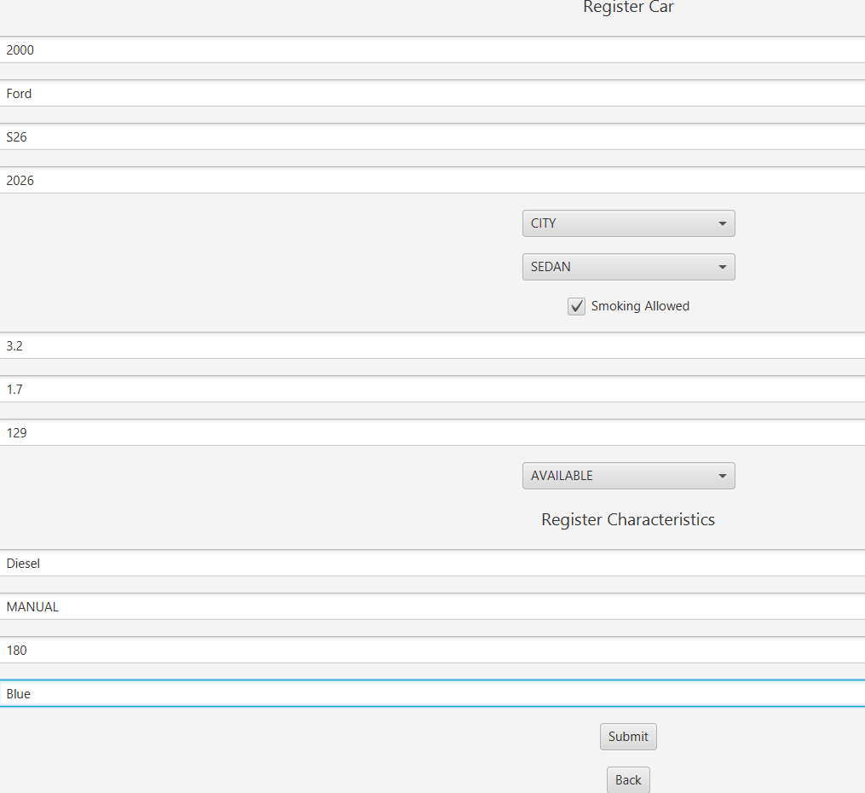
Figure 69. Register Car forms.

The database with the new Ford:
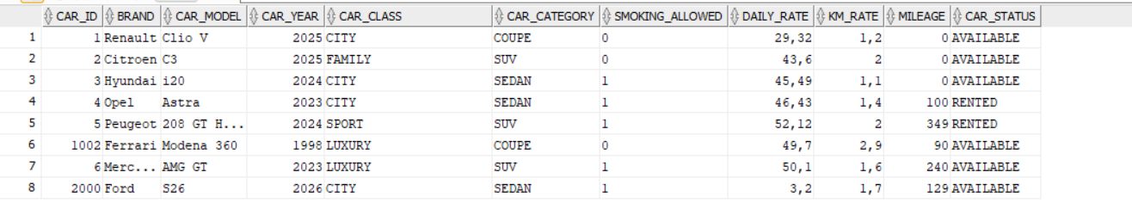
Figure 70. Table with the new car.
The Car Characteristics:
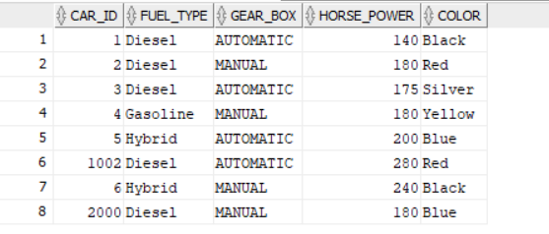
Figure 71. Table with the car characteristics.
We continue with the Database reports on option five.
Figure 72. Operator's Dashboard.

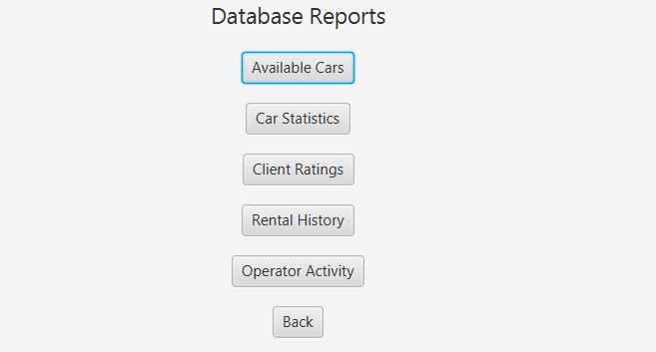
Figure 73. Database Reports.
Available Cars:
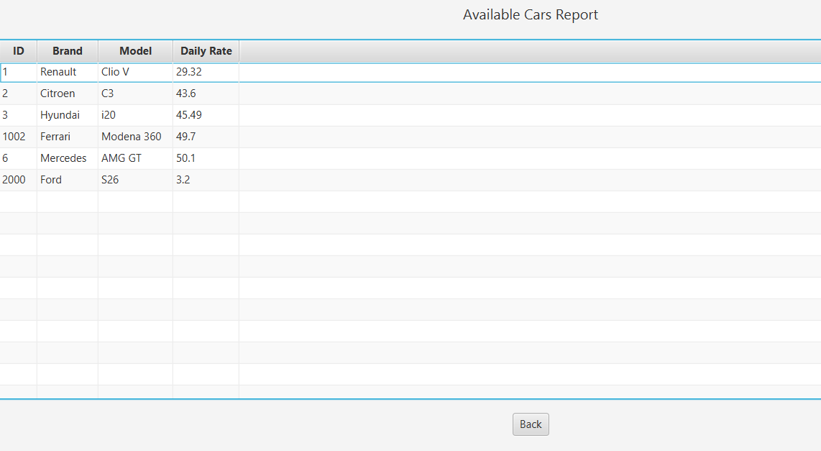
Figure 74. Result, available cars.

Car Statistics:
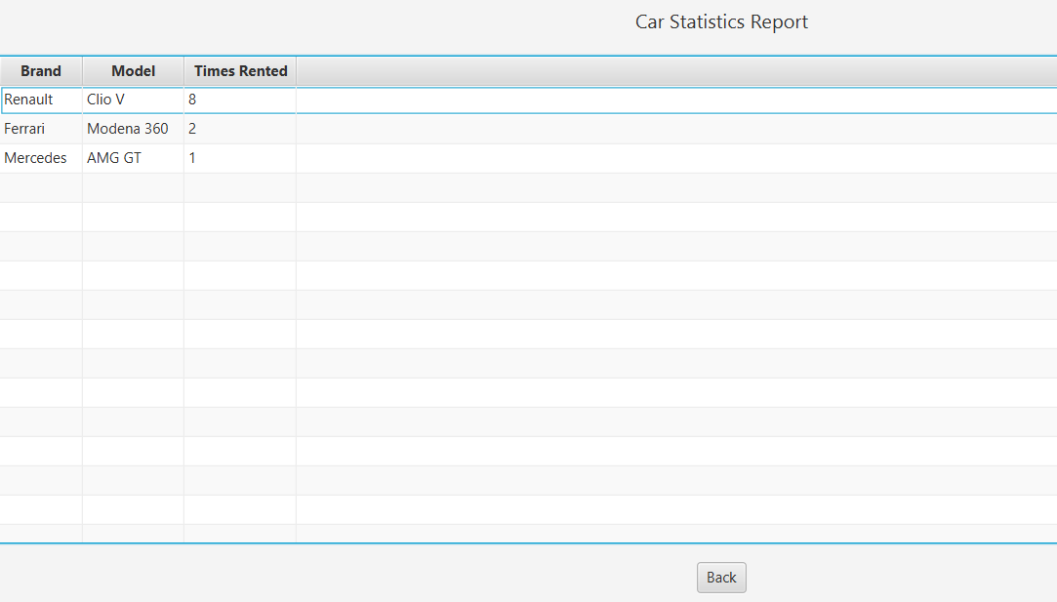
Figure 75. Query result, car statistics.
Client Ratings:
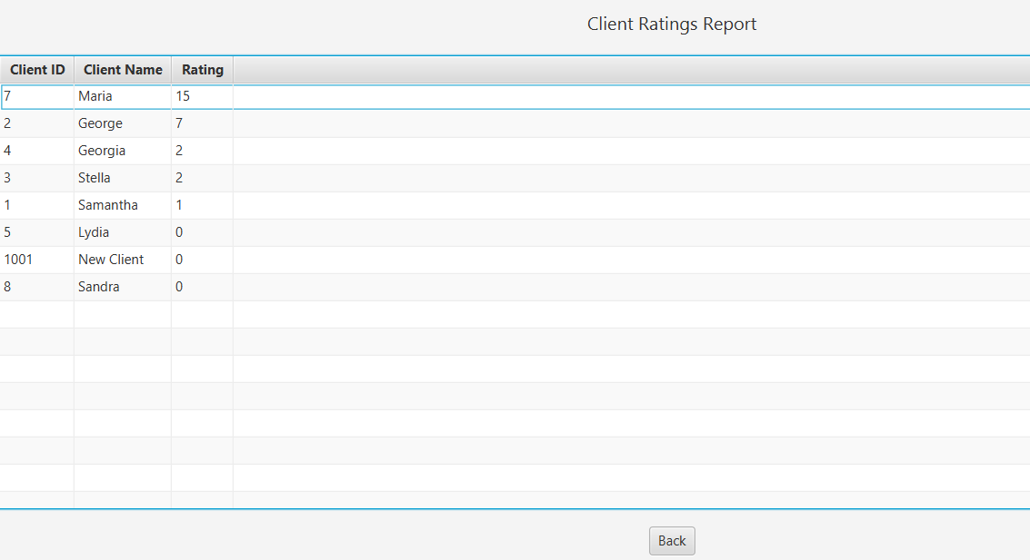
Figure 76. Query result, client ratings.

Rental History:
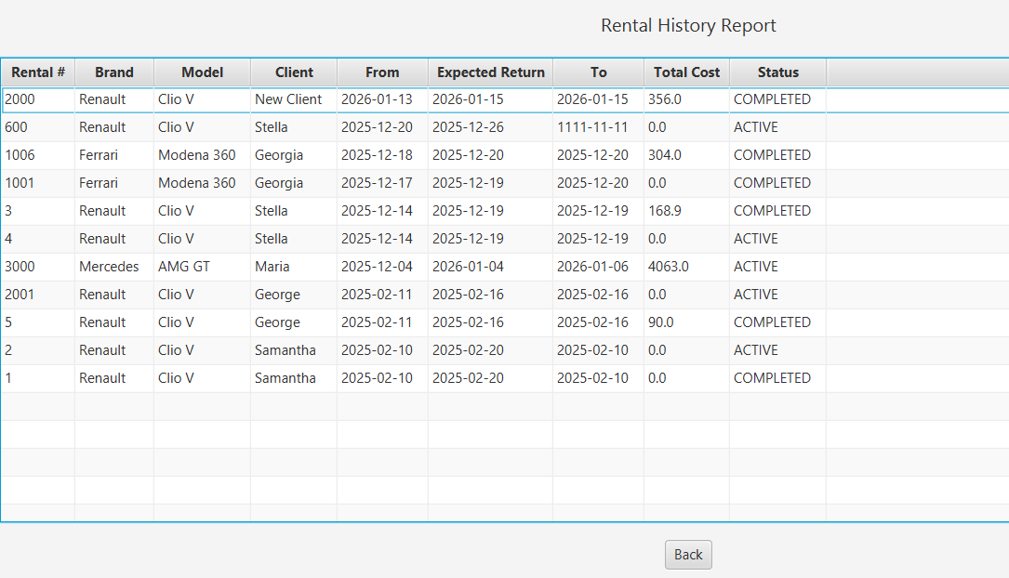
Figure 77. Query result, rental history.
Operator Activity:
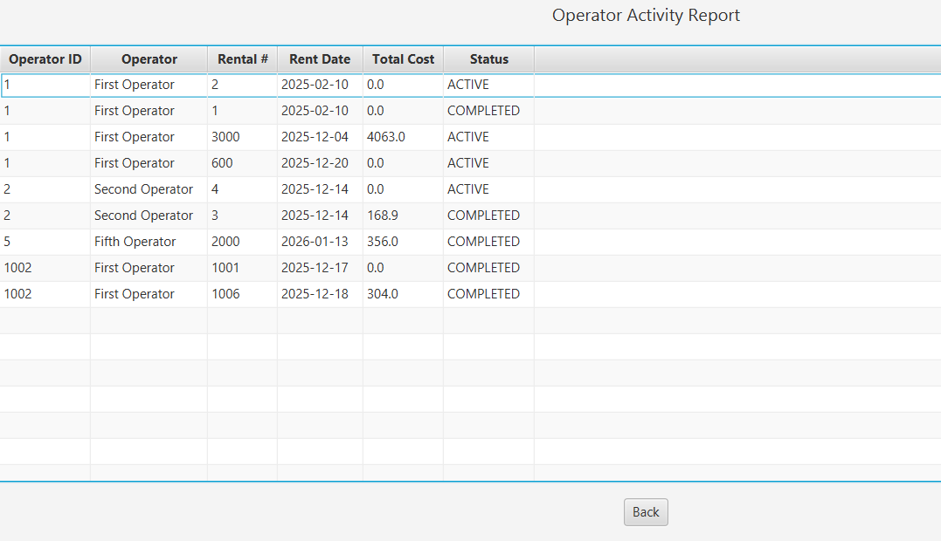
Figure 78. Query result, operator activity.

It is important to mention that each time the ‘Back’ button is pressed the previous page is loaded. Also with every option and operation done, validation messages are shown in the console.

- All the methods regarding the Database are situated in the Database package. And are used throughout the program by the AdminService, OperatorService and the controllers.
- All the methods contained in the controllers are called by the corresponding FXML file, which are called in the MainApp each time an option is pressed.
The testing of these methods is more thorough in the previous sub-chapter. As a whole, and as we saw in this one, the functioning is proper and correct.

Chapter 5. Conclusion
5.1 Summary of the implementation of the initial objectives
The Car Rental Project demonstrates an organized integration of Java application logic combined with a relational database system, which completes the primary goal of the project and creates a desktop application for managing car rental operations.
The Project’s database integration was made with ‘Database’ package where the classes ‘DatabaseConnection’ and ‘jpa’ provide a connection/communication with the Oracle. The JPA implementation on the database layer applies data integrity with foreign and primary keys.
Business logic is implemented in ‘service’. ‘AdminService’ and ‘OperatorService’ classes encrypt domain rules such as role management, rental cycle, company operations, different types of reports, pricing calculations, and damage evolution.
The .fxml files and ‘controller’ classes deliver an organized, clearly separated workflow that has event driven interface.
Requirements about reporting are fulfilled by methods in Database->jpa:
- Rental history
- Client ratings
- Vehicle availability and statistics
- Productivity of the operators

5.2 Directions for the future development and improvement
The current form of the Car Rental project works harmoniously there is always room for improvement. We can add new features to elevate both our project and the user experience.
- Data Validation and Security: Using an algorithm to encode passwords before saving them or putting some input restrictions would protect the wrong data from being entered. Also using more input validations throughout the program would prevent crashes and invalid inputs.
- New Features with methods: Systems that will allow the user to make a reservation or online payment would level up their user experience.
- User Interface Improvement: Regarding the presentation of the program, the interactive windows, forms etc.. There is room for improvement, css changes that can make the program look truly professional, colorful and attractive.
- Opportunitites for more complex, real-situation application. Where two ore more users can use the program, log in and execute the program efficiently. We are talking about a functioning, presentable project with real-business opportunities.
- One issue worth addressing is the co-existence of both JDBC and JPA in one program. Conversion from one to another is challenging. One idea is to keep only one of the two for the program’s database layer. Also the portability of the program is something to be considered about.

Thank you for using the Car Rental System – Tires and Roses!
~The development team

Link for GitHub repository
https://github.com/LilGhost44/TyresAndRoses

Bibliography and References
For JDBC
https://www.geeksforgeeks.org/java/introduction-to-jdbc/
https://docs.oracle.com/javase/tutorial/jdbc/basics/index.html
For JavaFX
https://gluonhq.com/products/javafx/
https://gluonhq.com/products/javafx/
https://www.jetbrains.com/help/idea/javafx.html
For log4j
https://logging.apache.org/log4j/2.x/index.html
https://en.wikipedia.org/wiki/Log4j
https://betterstack.com/community/guides/logging/how-to-start-logging-with-log4j/
https://www.ibm.com/think/topics/log4j
For Junit and testing
https://junit.org/
https://www.geeksforgeeks.org/advance-java/introduction-of-junit/
https://www.parasoft.com/blog/junit-tutorial-setting-up-writing-and-running-java-unit-tests/

